**Experiment 3**

**TITLE:** **DDL (Data Definition Language) commands with Data Constraints**

**Objective:** To understand the concept of data constraints that is enforced on data being stored in the table. Focus on Primary Key and the Foreign Key

**Create the tables described below:**

**Table name: CLIENT_MASTER_1**

**Description:** Used to store client information.

|  |  |  |  |
| --- | --- | --- | --- |
| **Column name** | **Data type** | **Size** | **Constraints** |
| CLIENTNO | Varchar | 6 | Primary key / first letter must start with ‘C’ |
| NAME | Varchar | 20 | Not Null |
| ADDRESS 1 | Varchar | 30 |  |
| ADDRESS 2 | Varchar | 30 |  |
| CITY | Varchar | 15 |  |
| PINCODE | Integer | 8 |  |
| STATE | Varchar | 15 |  |
| BALDUE | Decimal | 10,2 |  |

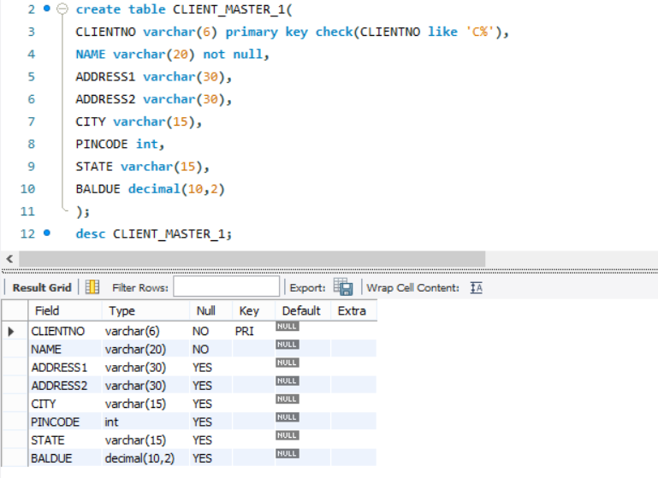

**Table Name: PRODUCT_MASTER_1 Description:** Used to store product information

|  |  |  |  |
| --- | --- | --- | --- |
| **Column name** | **Data type** | **Size** | **Attributes** |
| PRODUCTNO | Varchar | 6 | Primary Key/ first letter must start with ‘P’ |
| DESCRIPTION | Varchar | 15 | Not Null |
| PROFITPERCENT | Decimal | 4,2 | Not Null |
| UNIT MEASURE | Varchar | 10 | Not Null |
| QTYONHAND | Integer | 8 | Not Null |
| REORDERL VL | Integer | 8 | Not Null |
| SELLPRICE | Decimal | 8,2 | Not Null |
| COSTPRICE | Decimal | 8,2 | Not Null |

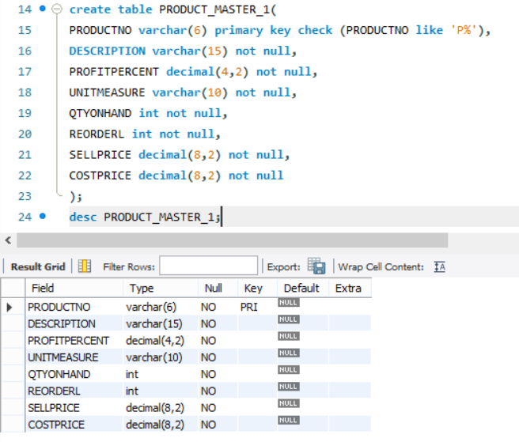

**Table Name: SALESMAN_MASTER _1**

**Description:**  used to store salesman information working for the company.

|  |  |  |  |
| --- | --- | --- | --- |
| **Column name** | **data type** | **Size** | **Attributes** |
| SALESMANNO | Varchar | 6 | Primary Key/ first letter must start with ‘S’ |
| SALESMANNAME | Varchar | 20 | Not Null |
| ADDRESS 1 | Varchar | 30 | Not Null |
| ADDRESS 2 | Varchar | 30 |  |
| CITY | Varchar | 20 |  |
| PINCODE | Integer | 8 |  |
| STATE | Varchar | 20 |  |
| SALAMT | Real | 8,2 | Not Null , Cannot be 0 |
| TGTTOGET | Decimal | 6,2 | Not Null , Cannot be 0 |
| YTDSALES | Double | 6,2 | Not Null |
| REMARKS | Varchar | 60 |  |

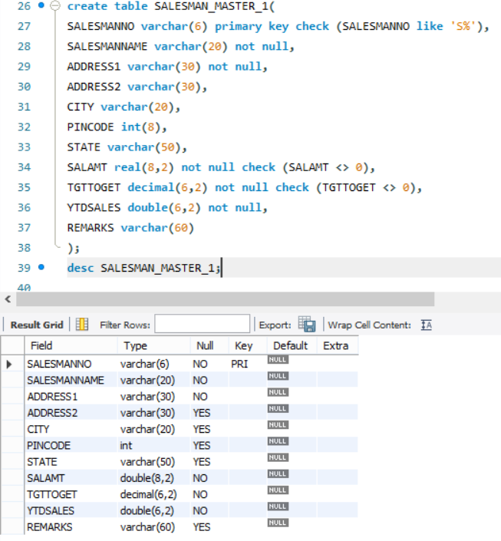

1. **Reinsert the data in these two tables based upon Lab 2.**
2. **Display the contents of each table.**

For CLIENT_MASTER_1:

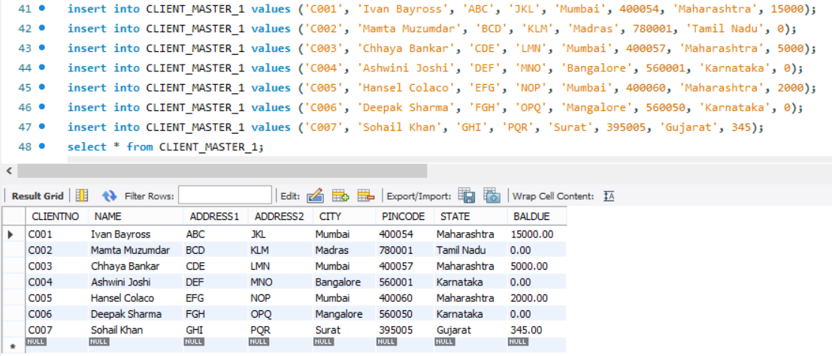

For PRODUCT_MASTER_1:

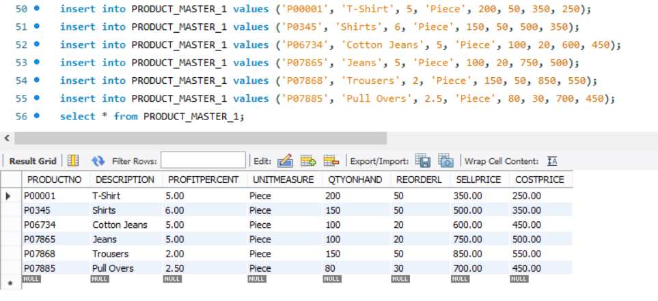

For SALESMAN_MASTER_1:

